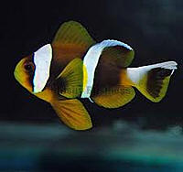

AN 001 Amphiprion  
Xanthurus  
Allard's clownfish

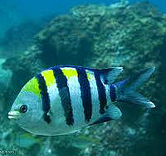

DA 001 Abudefduf  
Annulatus  
Striped Damsel

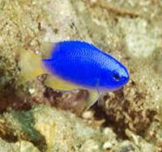

DA 002 Abudefduf  
Biocellatus  
Neon Damsel

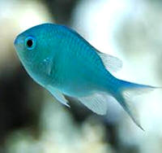

DA 007 Chromis  
Viridis  
Blue green Chromis

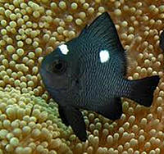

DA 010 Dascyllus   
Trimaculatus  
Threespotdamsel fish

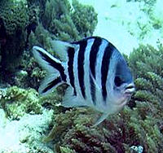

DA 004 Sex  
Fasciatus  
Stripetail Damsel

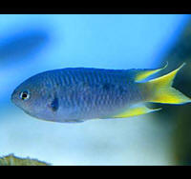

DA 011 Neopomacentrus   
Nemurus   
Gold tail cromis

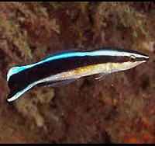

CL 001 Labroides  
Dimidiatus  
Cleaner wrasser

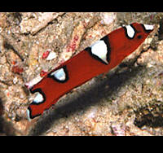

WR 007 Coris  
Africana Formosa  
Queen Coris

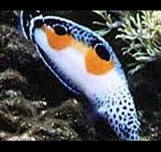

WR 011 Coris  
Angulata  
Clown coris

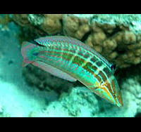

WR 013 Cirrhilabrus  
Exquisitus  
Exquisite wrasser

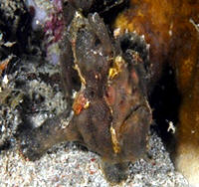

LF 010 Antennarius  
Ord  
Brown frogfish